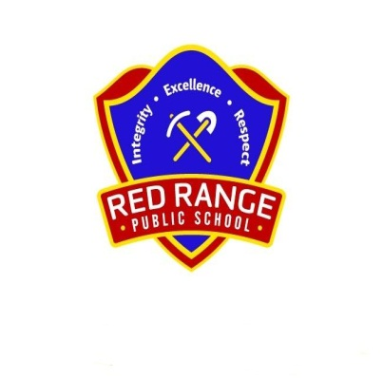
RED RANGE PUBLIC SCHOOL

9 March 2017

Dear Parent/Guardian/Carer

I am writing to advise you that we suspect that nits/head lice are present in the hair of some students within the school.

Please check your child’s hair for nits/lice tonight using the methods that have been recommended in information from NSW Health (http://www.health.nsw.gov.au/environment/headlice/Pages/ treatment.aspx). A copy of this information is attached.

If you find any eggs or lice please commence treatment as recommended.

Further information on head lice is available on the NSW Health website (details above) or through the Department’s website at http://www.schools.nsw.edu.au/studentsupport/studenthealth/ conditions/headlice/index.php.

I appreciate your assistance in this regard.

Yours sincerely

Lesley Burch
Relieving Principal

